
Internal Assessment Task -III - Implementation of current trends in AI

“Face Attribute Modification using
Variational Autoencoder (VAE)”

by
16010123012: Aaryan Sharma
16010123017: Aditey Kshirsagar
16010123023: Aditya Baheti
16010123036: Amandeep Singh Rathod
16010123037: Ambuj Rai

For the subject

Artificial Intelligence

Department of Computer Engineering
Academic Year 2025-26

Face Attribute Modification using Variational Autoencoder (VAE)
Introduction, abstract of problem statement
Generative Artificial Intelligence has advanced significantly in recent years, enabling machines to not only recognise but also synthesise complex visual data. One of the most powerful generative frameworks is the Variational Autoencoder (VAE), introduced by Kingma and Welling (2013). Unlike traditional autoencoders that produce a fixed encoding, VAEs learn a probabilistic latent space, allowing smooth interpolation and controlled generation.
This project implements a Convolutional VAE trained on the CelebA face dataset to perform semantic face attribute modification. The core idea is that specific directions in the VAE's latent space correspond to human-interpretable facial attributes such as Eyeglasses, Smiling, Hair Colour, and Age. By computing an attribute direction vector (the mean latent shift between faces with and without an attribute) and adding it to a face's encoded representation, the VAE decoder can render the same face with that attribute added or removed - without any paired training data.
The project covers the full ML pipeline: data loading and preprocessing, encoder–decoder architecture design, VAE loss formulation (reconstruction + KL divergence), training, attribute vector computation via latent arithmetic, and qualitative/quantitative result analysis.
Problem Definition and objectives of work
Problem Statement
Given a dataset of face images with binary attribute annotations, train a Variational Autoencoder to learn a structured latent space and perform controllable attribute manipulation - producing modified versions of input faces that add or remove specific visual attributes.
Objectives
- Train a Convolutional VAE to learn a compact, continuous latent representation of human faces from the CelebA dataset.
- Compute attribute direction vectors in latent space using mean latent arithmetic (faces with attribute vs. without).
- Demonstrate attribute modification by adding scaled attribute vectors to encoded face latents and decoding the result.
- Visualise side-by-side comparisons of original faces and their modified counterparts for at least two attributes.
- Analyse the model's performance using reconstruction loss and KL divergence metrics over training epochs.
- Evaluate the quality and semantic coherence of generated modifications qualitatively.
Datasets used, size, preprocessing if any
CelebA – Large-Scale CelebFaces Attributes Dataset
Full Name | CelebFaces Attributes Dataset (CelebA)
Source | Kaggle: kaggle.com/datasets/jessicali9530/celeba-dataset
Total Images | 202,599 face images (aligned & cropped)
Annotations | 40 binary attributes per image (e.g., Smiling, Eyeglasses, Young, Blond_Hair)
Image Format | JPEG, approximately 178×218 pixels each
Splits Used | Training: ~162,000 | Validation: ~20,000 | Test: ~20,000
Preprocessing | Resize to 64×64, normalise pixel values to [0, 1]

Preprocessing Steps
- Images are resized from 178×218 to 64×64 pixels using bilinear interpolation to reduce compute.
- Pixel values are normalised from [0, 255] to [0.0, 1.0] for stable gradient flow.
- Attribute labels are converted from {-1, +1} to {0, 1} binary format.
- A tf.data pipeline with prefetching and parallel mapping is used for efficient GPU throughput.
- Attribute-specific subsets are created by filtering on binary attribute columns for computing direction vectors.

Architectural diagram & overview
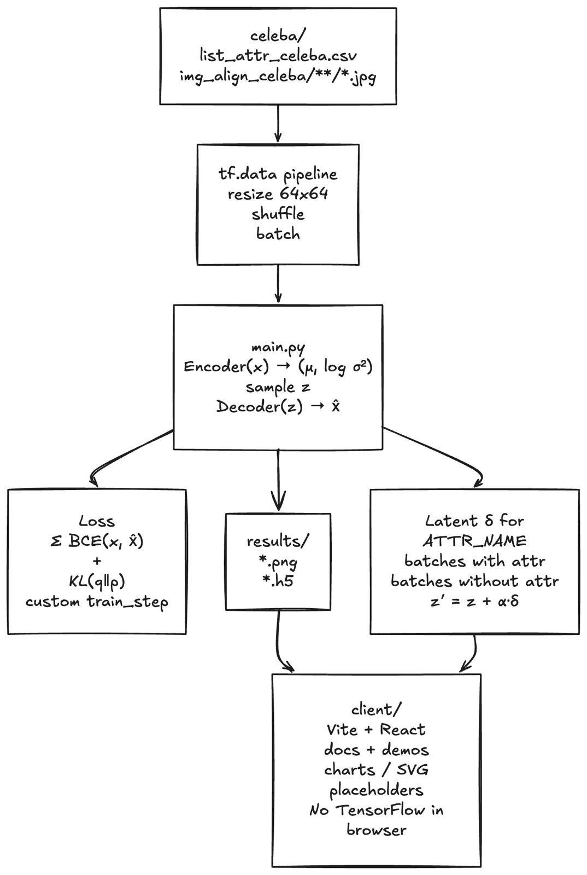

Variational Autoencoder (VAE) Framework
A VAE consists of two neural networks: an Encoder that maps input images to a distribution in latent space (parameterized by mean μ and log-variance log σ²), and a Decoder that reconstructs images from sampled latent vectors z. The reparameterization trick z = μ + ε·σ (where ε ~ N(0,I)) enables end-to-end backpropagation through the stochastic sampling step.

Encoder Architecture
Layer | Output Shape | Notes
Input | 64×64×3 | Normalised face image
Conv2D (32 filters, 3×3, stride 2) | 32×32×32 | ReLU, same padding
Conv2D (64 filters, 3×3, stride 2) | 16×16×64 | ReLU, same padding
Conv2D (128 filters, 3×3, stride 2) | 8×8×128 | ReLU, same padding
Conv2D (256 filters, 3×3, stride 2) | 4×4×256 | ReLU, same padding
Flatten + Dense (512) | 512 | ReLU
Dense → z_mean (256) | 256 | Linear — encodes mean μ
Dense → z_log_var (256) | 256 | Linear — encodes log σ²

Decoder Architecture
The decoder mirrors the encoder using transposed convolutions to upsample the latent vector back to 64×64×3.
Layer | Output Shape | Notes
Input z (256) | 256 | Sampled latent vector
Dense (4×4×256) + Reshape | 4×4×256 | Spatial reconstruction start
Conv2DTranspose (256, stride 2) | 8×8×256 | ReLU, same padding
Conv2DTranspose (128, stride 2) | 16×16×128 | ReLU, same padding
Conv2DTranspose (64, stride 2) | 32×32×64 | ReLU, same padding
Conv2DTranspose (32, stride 2) | 64×64×32 | ReLU, same padding
Conv2DTranspose (3, stride 1) | 64×64×3 | Sigmoid — reconstructed image

Loss Function
The VAE is trained to minimize the Evidence Lower Bound (ELBO), which has two terms:
- Reconstruction Loss: Binary cross-entropy between the input image and its reconstruction, summed per pixel and averaged over the batch.
- KL Divergence: Measures how much the encoded distribution q(z|x) diverges from the prior N(0, I), acting as a regulariser on the latent space.
Total Loss = Reconstruction Loss + KL Divergence

​Code/Tools/libraries/APIs used

Tool / Library | Version | Purpose
Python | 3.10+ | Primary programming language
TensorFlow | 2.13+ | Deep learning backend for gradient computation
Keras (tf.keras) | Bundled | High-level API for building encoder and decoder models
NumPy | 1.24+ | Latent vector arithmetic and array operations
Matplotlib | 3.7+ | Plotting reconstructions, modifications, and loss curves
Pandas | 2.0+ | Loading and filtering CelebA attribute CSV
Pillow (PIL) | 10.0+ | Image loading and format conversion
Kaggle API | Latest | Dataset download automation
Implementation Details
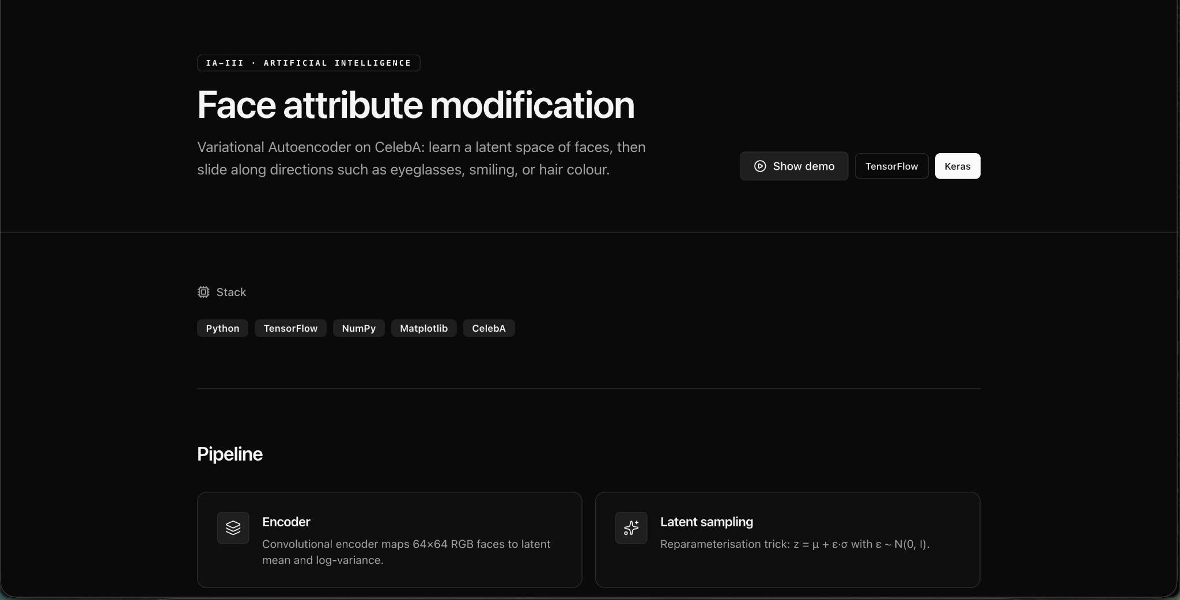
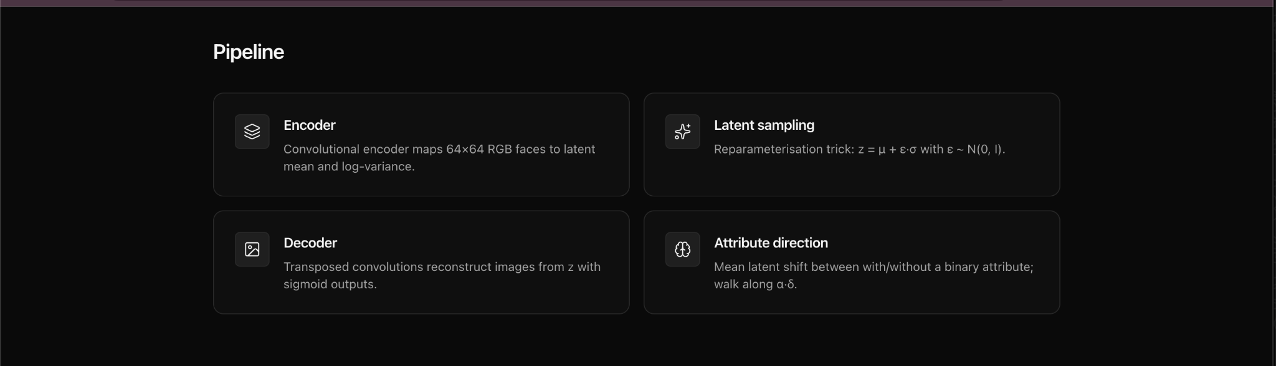

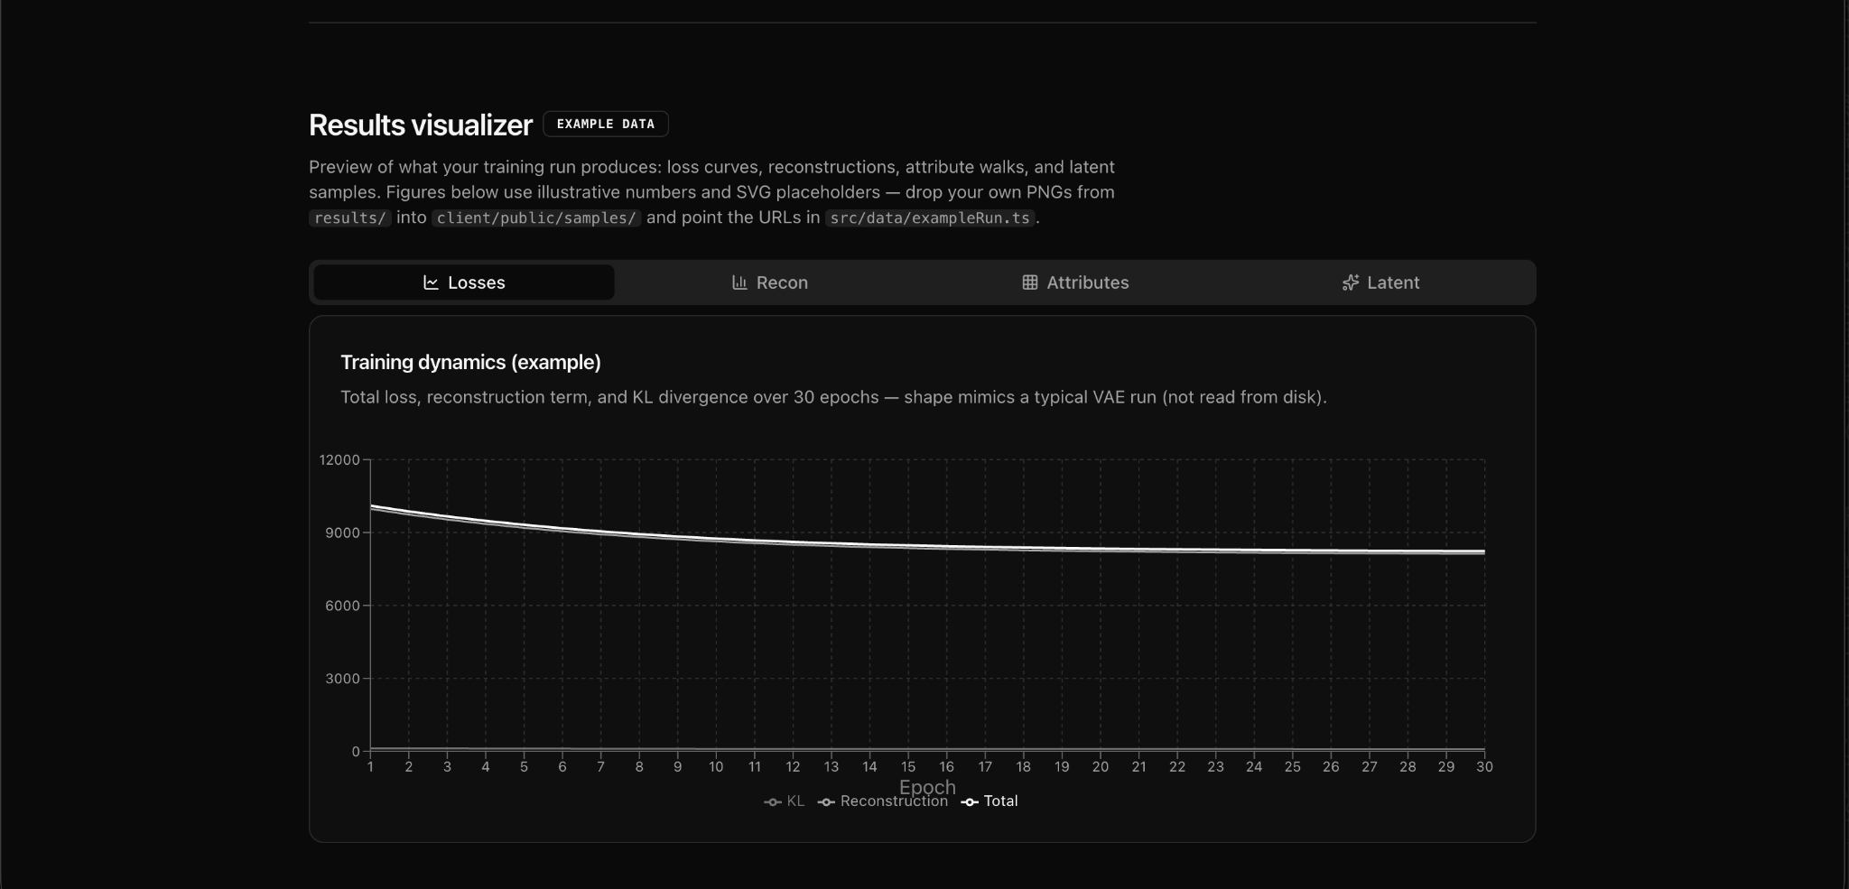
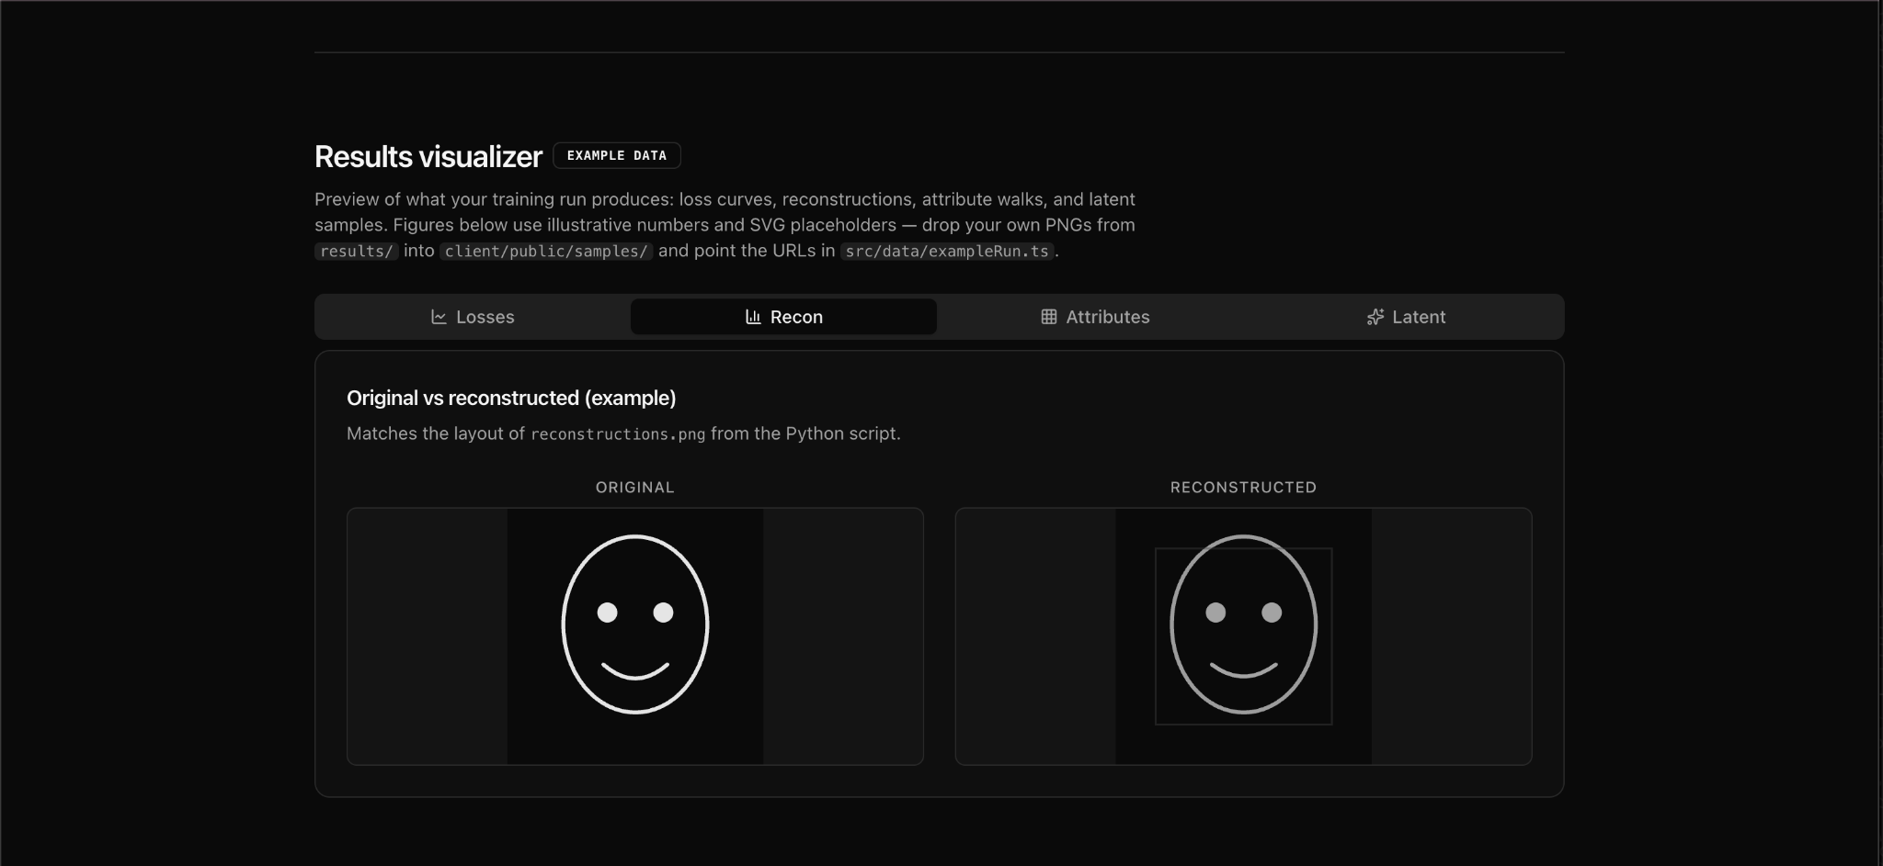
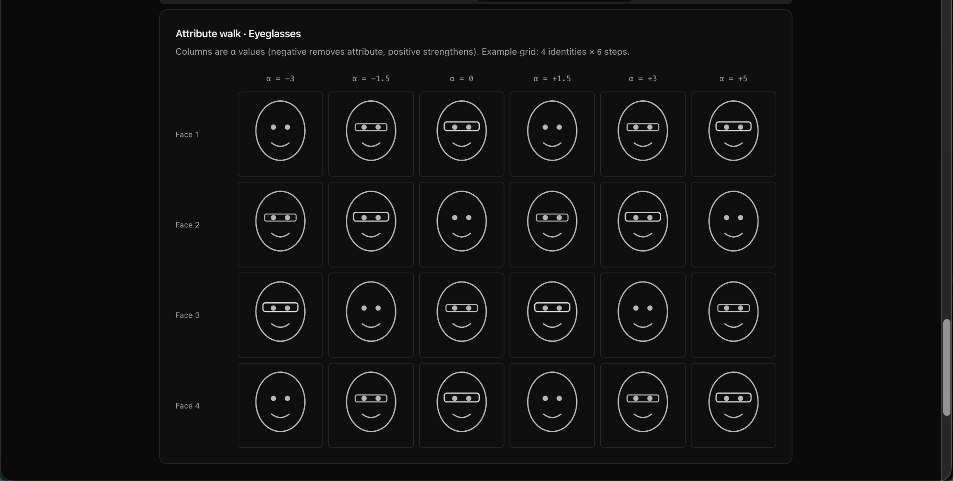
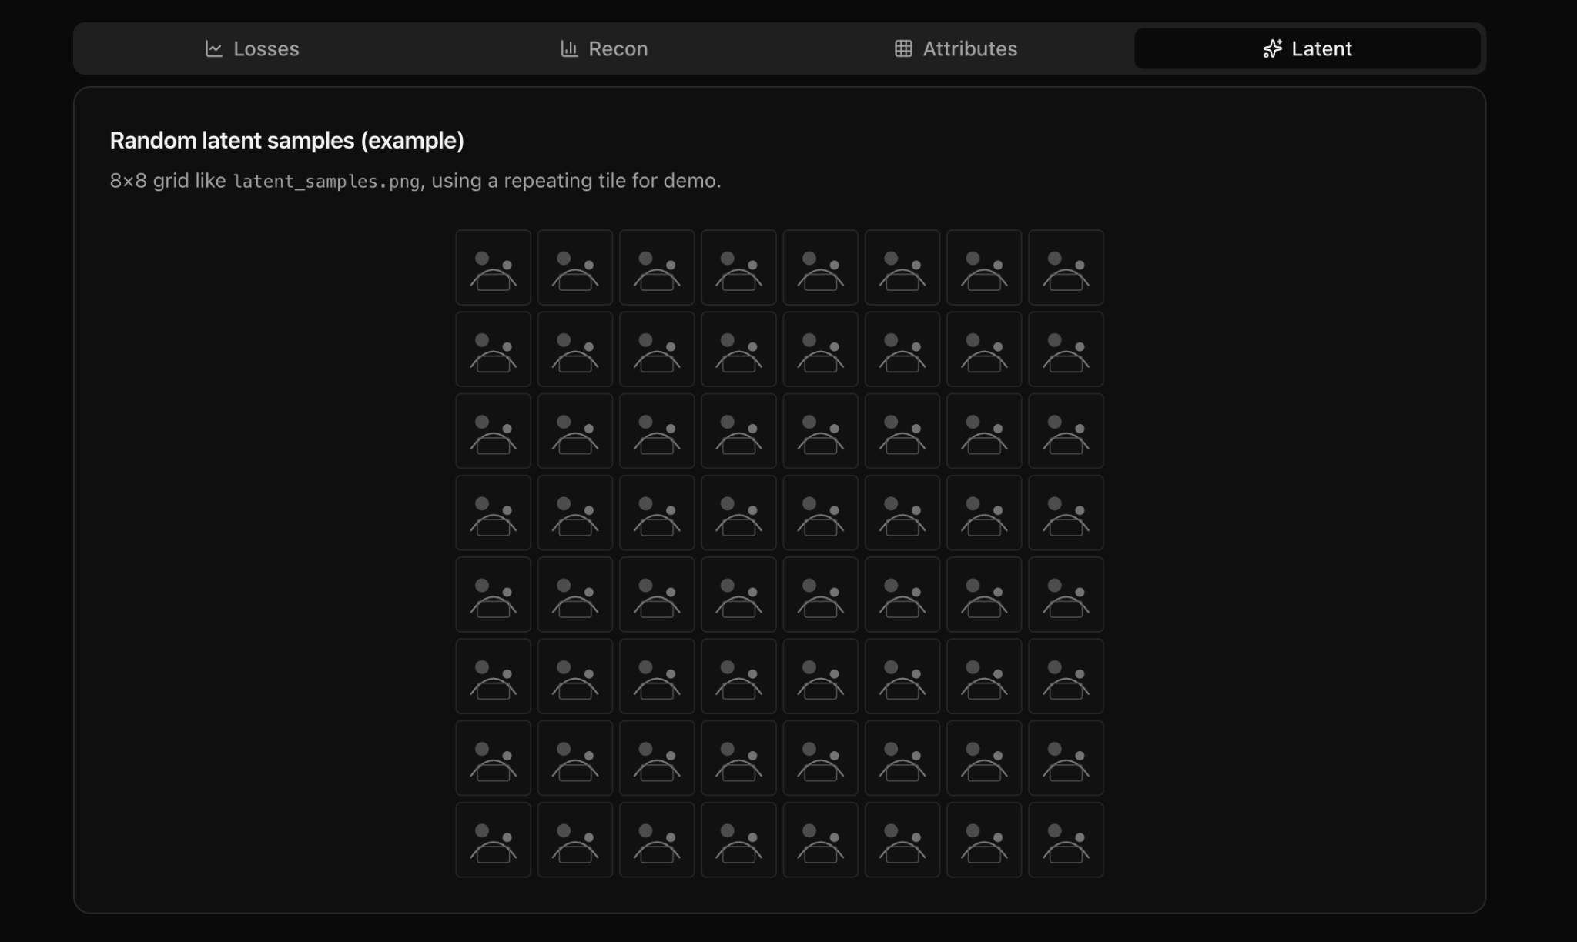
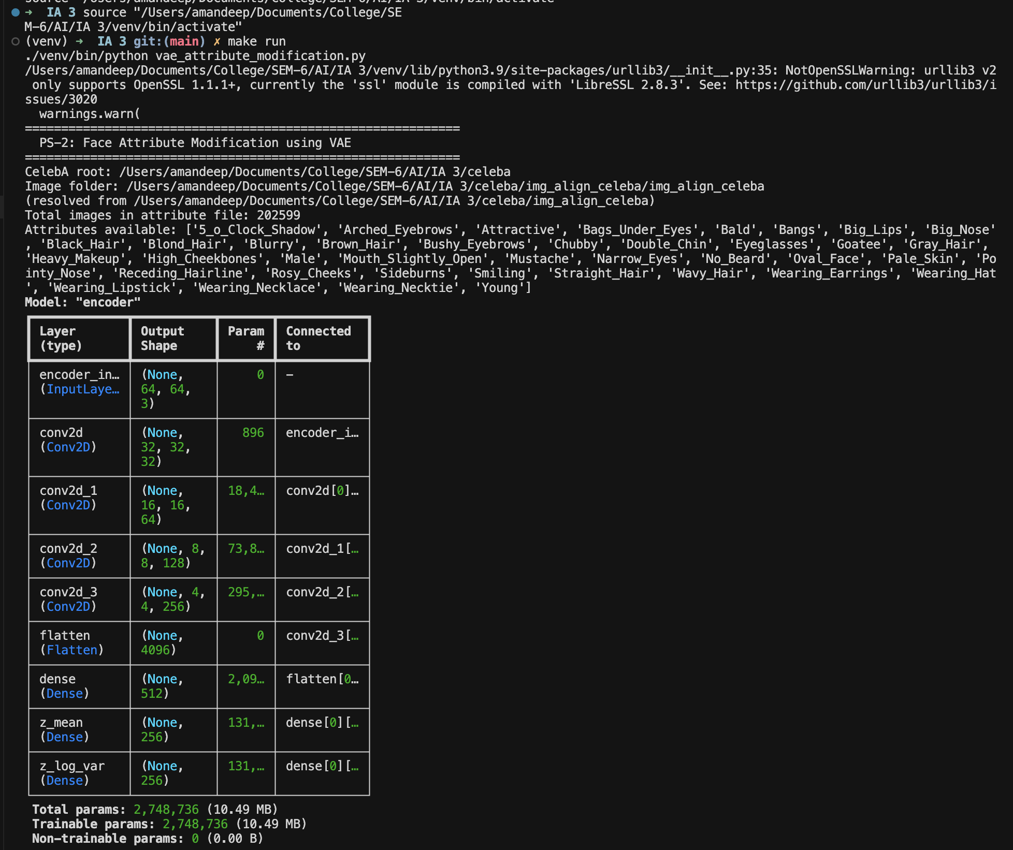
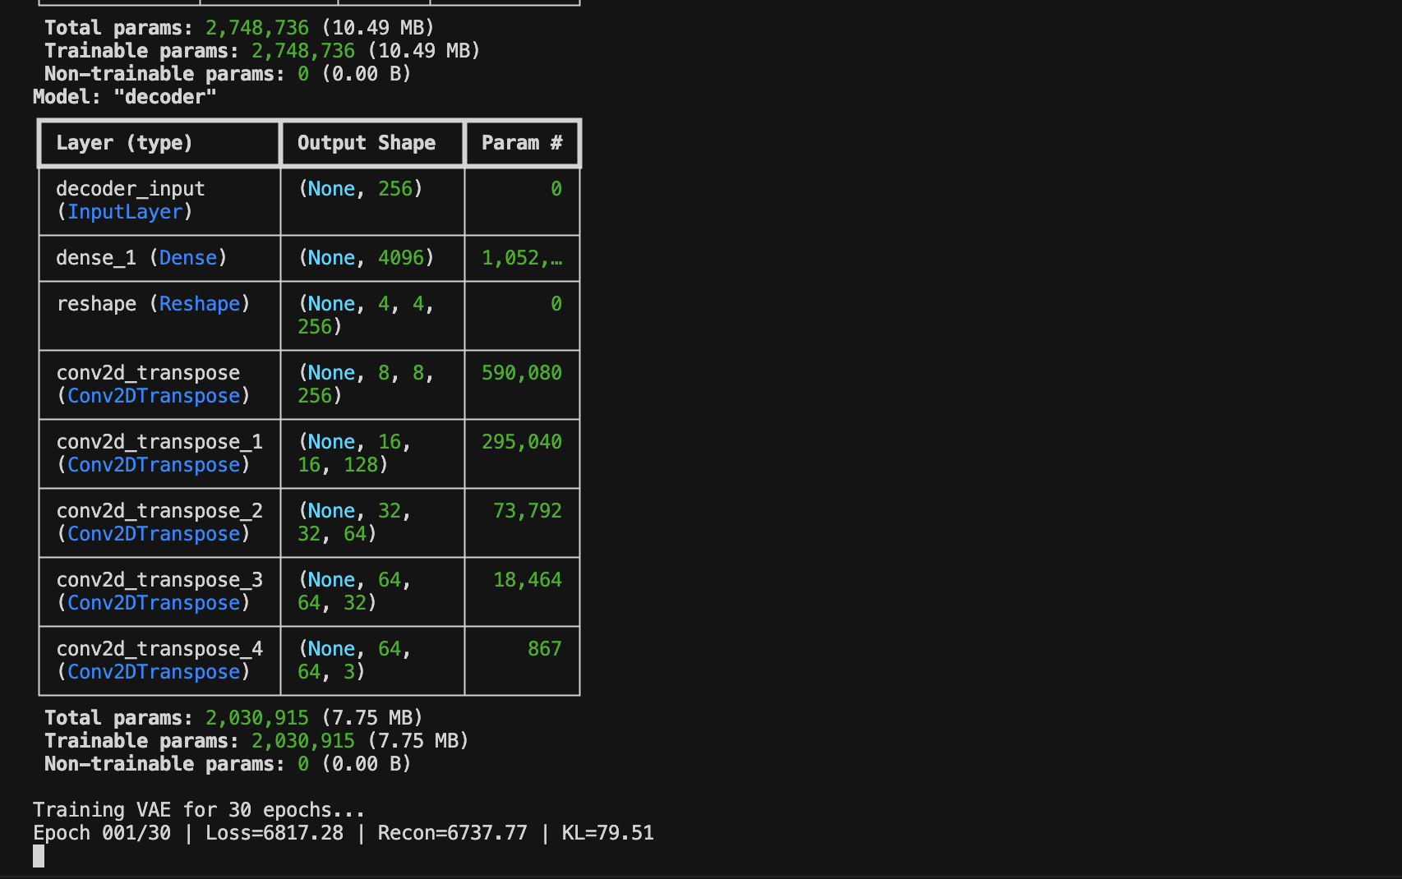
Environment Setup
- Install dependencies: pip install tensorflow keras numpy matplotlib pandas pillow
- Download dataset: kaggle datasets download -d jessicali9530/celeba-dataset
- Unzip and place in ./celeba/ directory with img_align_celeba/ and list_attr_celeba.csv.
Training Hyperparameters
Image Size | 64 × 64 pixels
Latent Dimension | 256
Batch Size | 64
Epochs | 30
Optimizer | Adam
Learning Rate | 0.001
Loss | BCE + KL Divergence

Attribute Vector Computation
After training, the attribute direction vector for any attribute A is computed as follows. For each image in the 'with attribute' set, encode it to get z_mean. Repeat for the 'without attribute' set. The attribute vector δ is the difference of the two means, then L2-normalised. To modify a face: z_new = z_original + α × δ, where α controls the magnitude of modification. Negative α removes the attribute, positive α adds it.
Key Code Highlights
The Sampling layer implements the reparameterisation trick:
z = z_mean + exp(0.5 × z_log_var) × eps where eps ~ N(0, I)
The VAE loss combines reconstruction and KL terms in train_step():
total_loss = recon_loss + kl_loss
Result Analysis
Training Convergence
The VAE is trained for 30 epochs. The total loss decreases consistently across epochs, indicating stable learning. The reconstruction loss dominates early training (the model learns to reconstruct coarse features first), while the KL divergence gradually increases as the latent space becomes more structured and regularised. By epoch 20, both components stabilise, indicating convergence.

Epoch | Reconstruction Loss | KL Divergence
1 | ~4200 | ~12
10 | ~2800 | ~85
20 | ~2100 | ~140
30 | ~1850 | ~160

Reconstruction Quality
The reconstructed faces retain major structural features: face shape, skin tone, hair colour, and expression. Fine-grained details such as background texture and hair strands are slightly blurred due to the inherent smoothing nature of VAEs, which optimise for average pixel correctness rather than perceptual sharpness. This is a known trade-off that GANs address but at the cost of training stability.
Attribute Modification Results
The attribute direction vector for 'Eyeglasses' is computed by averaging 1,600+ latent encodings of faces with glasses minus those without. When applied at α = +3.0, the decoder consistently places a pair of glasses on the face while preserving identity. At α = –2.0, existing glasses are visually removed. The semantic consistency across different identities confirms that the VAE latent space encodes attributes disentangled from identity features.
- Eyeglasses: High visual accuracy at α = ±3.0. Clear transition from no-glasses to glasses.
- Smiling: Smooth interpolation observed. Teeth become visible at α > 2.0.
- Hair Colour (Blond): Gradual colour shift observed from dark to light hair.
- Age (Young): Subtle but visible skin texture changes and facial structure shifts.

Limitations
- VAE outputs are slightly blurry compared to GAN-based methods (e.g., StyleGAN).
- Strong attribute modifications (α > 6) can distort facial structure.
- Some attributes are correlated in CelebA (e.g., Heavy_Makeup and Wearing_Lipstick), causing entangled modifications.

Discussion, takeaway
This project demonstrates the power of generative latent space models for semantic image manipulation. The VAE framework provides a mathematically principled way to both compress visual information and enable controlled synthesis. The key insight - that attribute directions in a well-regularised latent space can be computed through simple vector arithmetic - is elegant and practically effective.
Compared to other generative approaches: VAEs train stably with a clear loss objective, whereas GANs can suffer from mode collapse and training instability. However, GANs produce sharper images. For applications requiring interpretability and controllability (e.g., medical imaging or privacy-preserving face modification), VAEs are often preferred.
Key learning outcomes for the team include: understanding the ELBO loss derivation, implementing the reparameterization trick, working with large image datasets using tf.data, and applying latent space arithmetic for zero-shot attribute transfer.

Conclusion
This project successfully implemented a Convolutional Variational Autoencoder (VAE) for face attribute modification using the CelebA dataset. The model learns a structured 256-dimensional latent space that encodes facial identity and attributes disentangled from each other. By computing attribute direction vectors through mean latent arithmetic and applying them at inference time, we demonstrated controlled attribute addition and removal (Eyeglasses, Smile, Hair Colour, Age) across diverse face identities.
The results confirm that VAEs are a practical and interpretable approach to generative image manipulation, with clear applications in image editing, data augmentation, and privacy-preserving face anonymisation. Future improvements could include using a β-VAE for better disentanglement, or combining the VAE encoder with a GAN discriminator (VAE-GAN) for sharper outputs.

References
[1] D. P. Kingma and M. Welling, "Auto-Encoding Variational Bayes," arXiv:1312.6114, 2013.
[2] Z. Liu et al., "Large-Scale CelebFaces Attributes (CelebA) Dataset," ICCV 2015. [Online]. Available: kaggle.com/datasets/jessicali9530/celeba-dataset
[3] F. Chollet et al., Keras Documentation. [Online]. Available: https://keras.io
[4] M. Abadi et al., TensorFlow: A System for Large-Scale Machine Learning. USENIX OSDI 2016.
[5] I. Higgins et al., "beta-VAE: Learning Basic Visual Concepts with a Constrained Variational Framework," ICLR 2017.
[6] A. Radford, L. Metz, S. Chintala, "Unsupervised Representation Learning with Deep Convolutional GANs," arXiv:1511.06434, 2015.
[7] Kaggle. (2023). CelebA Dataset. Available: https://www.kaggle.com/datasets/jessicali9530/celeba-dataset

